Supplementary Information

**Table S1. Dataset of SARS-CoV-2 S protein sequences downloaded**

|  |  |  |  |  |  |  |
| --- | --- | --- | --- | --- | --- | --- |
| Time period | Africa (case/variant) | Asia  (case/variant) | Europe  (case/variant) | North America  (case/variant) | Oceania  (case/variant) | South America  (case/variant) |
| Jan-Mar, 2020 | 94/13 | 2,274/214 | 1,406/104 | 10,055/400 | 854/64 | 149/15 |
| Apr-Jun, 2020 | 778/105 | 2,808/347 | 1,444/126 | 19,662/968 | 977/68 | 410/44 |
| Jul-Sep, 2020 | 645/100 | 2,100/242 | 1,675/145 | 18,434/1,159 | 8,240/229 | 116/32 |
| Oct-Dec, 2020 | 1,192/268 | 2,661/348 | 1,885/224 | 45,478/3,264 | 425/63 | 319/95 |
| Jan-Mar, 2021 | 1,589/393 | 1,248/323 | 3,319/451 | 140,838/10,916 | 98/36 | 356/138 |
| Apr-Jun, 2021 | 1,447/358 | 2,157/469 | 1,584/359 | 177,356/11,233 | 61/23 | 2,273/489 |
| Jul-Sep, 2021 | 1,933/491 | 4,703/812 | 3,416/546 | 382,456/21,392 | 2,017/47 | 4,771/824 |
| Oct-Dec, 2021 | 1,281/235 | 3,969/730 | 3,069/617 | 461,734/25,974 | 2,551/92 | 4,147/760 |
| Jan-Mar, 2022 | 720/95 | 8,648/727 | 1,939/271 | 247,674/9,632 | 2,611/119 | 1,948/140 |
| Apr-Jun, 2022 | 854/157 | 2,777/367 | 2,168/300 | 261,252/8,397 | 2,603/217 | 88/30 |
| Jul-Sep, 2022 | 298/75 | 4,178/605 | 1,162/214 | 253,298/11,225 | 2/2 | 106/32 |
| Oct-Dec, 2022 | 250/61 | 2,268/534 | 379/144 | 147,966/11,044 | 18/6 | 17/5 |
| Jan-Mar, 2023 | 35/21 | 1,087/324 | 121/64 | 90,796/8,895 | / | 49/24 |
| Apr-Jun, 2023 | 11/7 | 908/301 | 146/74 | 22,424/3,707 | / | 76/38 |
| Jul-Sep, 2023 | 4/3 | 667/317 | 44/31 | 38,369/5,797 | / | / |
| Oct-Dec, 2023 | / | 313/156 | 180/101 | 44,399/6,486 | / | / |
| Jan-Mar, 2024 | / | 160/79 | 43/17 | 26,275/3,216 | / | / |
| Apr-May, 2024 | / | 10/9 | / | 2,170/543 | / | / |
| Subtotal | 11,131/2,382 | 43,249/6,904 | 23,980/3,788 | 2,390,636/144,248 | 20,457/966 | 14,825/2,604 |
| Total | 2,504,278/160,892*，including 135,492 unique variant sequences. | | | | | |

* The variant number is the result of accumulation over time periods, so the real variants are smaller than this number.

Supplementary Table 2 Profiles of SARS-cov-2 variants in Africa: lineage, mutation details, Fitness, and IEIs

|  |  |  |  |  |  |  |  |  |  |
| --- | --- | --- | --- | --- | --- | --- | --- | --- | --- |
|  | Case /  Variant sequence | Dominant Lineage | Dominant Percentage* | Unique  Lineages | MMut | MaxFit | MFit | MaxIEI | MIEI |
| Jan-Mar, 2020 | 94/13 | B.1 | 30.77% | 9 | 2 | 0.213 | 0.204 | 0.168 | 0.156 |
| Apr-Jun, 2020 | 778/105 | B.1 | 32.38% | 29 | 2 | 0.306 | 0.207 | 0.299 | 0.158 |
| Jul-Sep, 2020 | 645/100 | B.1 | 34.0% | 28 | 2 | 0.283 | 0.210 | 0.349 | 0.163 |
| Oct-Dec, 2020 | 1,192/268 | B.1 | 23.51% | 54 | 9 | 0.370 | 0.228 | 0.350 | 0.204 |
| Jan-Mar, 2021 | 1,580/393 | B.1.1.7 | 20.36% | 48 | 9 | 0.372 | 0.257 | 0.369 | 0.253 |
| Apr-Jun, 2021 | 1,447/358 | B.1.1.7 | 22.91% | 39 | 11 | 0.376 | 0.299 | 0.371 | 0.264 |
| Jul-Sep, 2021 | 1,933/491 | AY.36 | 23.63% | 50 | 11 | 0.388 | 0.356 | 0.350 | 0.241 |
| Oct-Dec, 2021 | 1,281/235 | B.1.617.2 | 14.89% | 54 | 12 | 0.738 | 0.397 | 0.415 | 0.262 |
| Jan-Mar, 2022 | 720/95 | BA.1.1 | 37.89% | 25 | 38 | 0.771 | 0.513 | 0.437 | 0.308 |
| Apr-Jun, 2022 | 854/157 | BA.2 | 24.20% | 30 | 33 | 0.737 | 0.643 | 0.415 | 0.363 |
| Jul-Sep, 2022 | 298/75 | BA.5.2.1 | 16.00% | 33 | 35 | 0.831 | 0.676 | 0.472 | 0.380 |
| Oct-Dec, 2022 | 250/61 | BQ.1.1 | 22.95% | 26 | 38 | 0.813 | 0.751 | 0.459 | 0.424 |
| Jan-Mar, 2023 | 35/21 | BQ.1.1 | 14.29% | 14 | 38 | 0.842 | 0.780 | 0.478 | 0.441 |
| Apr-Jun, 2023 | 11/7 | XBB.1.16.2 | 28.57% | 5 | 45 | 0.886 | 0.853 | 0.508 | 0.487 |
| Jul-Sep, 2023 | 4/3 | XBB.1.16.2 | 33.33% | 3 | 45 | 0.938 | 0.892 | 0.564 | 0.519 |
| Oct-Dec, 2023 | / | / | / | / | / | / | / | / | / |
| Jan-Mar, 2024 | / | / | / | / | / | / | / | / | / |
| Apr-May, 2024 | / | / | / | / | / | / | / | / | / |

* Dominant Percentage: (num of dominant lineage) / (num of variant);

Mean Mutations per variant sequence: MMut; Maximum Fitness: MaxFit; Mean Fitness: MFit;

Maximum Immune Escape Index: MaxIEI; Mean Immune Escape Index: MIEI

Supplementary Table 3 Profiles of SARS-cov-2 variants in Asia: lineage, mutation details, Fitness, and IEIs

|  |  |  |  |  |  |  |  |  |  |
| --- | --- | --- | --- | --- | --- | --- | --- | --- | --- |
|  | Case /  Variant sequence | Dominant Lineage | Dominant Percentage* | Unique  Lineages | MMut | MaxFit | MFit | MaxIEI | MIEI |
| Jan-Mar, 2020 | 2,274/214 | B.1.1.63 | 14.41% | 48 | 2 | 0.373 | 0.212 | 0.489 | 0.168 |
| Apr-Jun, 2020 | 2,808/347 | B.1 | 13.21% | 63 | 2 | 0.328 | 0.211 | 0.368 | 0.165 |
| Jul-Sep, 2020 | 2,100/242 | B.1.1.63 | 13.88% | 57 | 2 | 0.370 | 0.214 | 0.330 | 0.167 |
| Oct-Dec, 2020 | 2,661/348 | B.1.1.312 | 9.48% | 62 | 3 | 0.373 | 0.214 | 0.348 | 0.166 |
| Jan-Mar, 2021 | 1,248/323 | B.1.1.7 | 16.10% | 59 | 5 | 0.595 | 0.256 | 0.402 | 0.211 |
| Apr-Jun, 2021 | 2,157/469 | B.1.617.2 | 31.56% | 57 | 11 | 0.700 | 0.318 | 0.389 | 0.238 |
| Jul-Sep, 2021 | 4,703/812 | B.1.617.2 | 29.56% | 78 | 15 | 0.612 | 0.363 | 0.358 | 0.244 |
| Oct-Dec, 2021 | 3,969/730 | B.1.617.2 | 20.82% | 89 | 12 | 0.600 | 0.372 | 0.350 | 0.246 |
| Jan-Mar, 2022 | 8,648/727 | BA.2 | 23.38% | 60 | 32 | 0.760 | 0.521 | 0.431 | 0.309 |
| Apr-Jun, 2022 | 2,777/367 | BA.2 | 28.07% | 66 | 32 | 0.707 | 0.604 | 0.396 | 0.345 |
| Jul-Sep, 2022 | 4,178/605 | BA.5.2 | 23.14% | 136 | 37 | 0.773 | 0.688 | 0.438 | 0.386 |
| Oct-Dec, 2022 | 2,268/534 | XBB.1 | 11.99% | 166 | 37 | 0.840 | 0.742 | 0.474 | 0.416 |
| Jan-Mar, 2023 | 1,087/324 | BF.5 | 7.41% | 142 | 41 | 0.876 | 0.778 | 0.504 | 0.438 |
| Apr-Jun, 2023 | 908/301 | XBB.1.16 | 8.31% | 122 | 43 | 0.898 | 0.844 | 0.515 | 0.480 |
| Jul-Sep, 2023 | 667/317 | XBB.1.16 | 6.94% | 130 | 44 | 0.935 | 0.866 | 0.547 | 0.496 |
| Oct-Dec, 2023 | 313/156 | HK.3 | 7.69% | 78 | 56 | 0.928 | 0.896 | 0.551 | 0.520 |
| Jan-Mar, 2024 | 160/79 | JN.1 | 20.25% | 32 | 66 | 0.963 | 0.944 | 0.592 | 0.569 |
| Apr-May, 2024 | 10/9 | XDQ.1 | 30.00% | 8 | 66 | 0.958 | 0.947 | 0.590 | 0.574 |

* Dominant Percentage: (num of dominant lineage)/(num of variant);

Mean Mutations per variant sequence: MMut; Maximum Fitness: MaxFit; Mean Fitness: MFit;

Maximum Immune Escape Index: MaxIEI; Mean Immune Escape Index: MIEI

Supplementary Table 4 Profiles of SARS-cov-2 variants in Europe: lineage, mutation details, Fitness, and IEIs

|  |  |  |  |  |  |  |  |  |  |
| --- | --- | --- | --- | --- | --- | --- | --- | --- | --- |
|  | Case /  Variant sequence | Dominant Lineage | Dominant Percentage* | Unique  Lineages | MMut | MaxFit | MFit | MaxIEI | MIEI |
| Jan-Mar, 2020 | 1,406/104 | B.1 | 47.12% | 25 | 2 | 0.270 | 0.209 | 0.255 | 0.159 |
| Apr-Jun, 2020 | 1,444/126 | B.1 | 55.56% | 25 | 2 | 0.380 | 0.223 | 0.309 | 0.183 |
| Jul-Sep, 2020 | 1,675/145 | B.1.160 | 37.24% | 32 | 3 | 0.311 | 0.211 | 0.339 | 0.168 |
| Oct-Dec, 2020 | 1,885/224 | B.1.160 | 38.39% | 35 | 3 | 0.328 | 0.214 | 0.352 | 0.169 |
| Jan-Mar, 2021 | 3,319/451 | B.1.1.7 | 29.05% | 69 | 5 | 0.416 | 0.273 | 0.343 | 0.216 |
| Apr-Jun, 2021 | 1,584/359 | B.1.1.7 | 71.87% | 40 | 11 | 0.378 | 0.291 | 0.370 | 0.229 |
| Jul-Sep, 2021 | 3,416/546 | AY.43 | 28.02% | 68 | 11 | 0.507 | 0.369 | 0.336 | 0.245 |
| Oct-Dec, 2021 | 3,069/617 | AY.43 | 22.20% | 83 | 12 | 0.597 | 0.366 | 0.370 | 0.241 |
| Jan-Mar, 2022 | 1,939/271 | BA.2 | 25.46% | 43 | 33 | 0.627 | 0.513 | 0.359 | 0.304 |
| Apr-Jun, 2022 | 2,168/300 | BA.2 | 44.33% | 64 | 34 | 0.751 | 0.638 | 0.421 | 0.359 |
| Jul-Sep, 2022 | 1,162/214 | BA.5.1 | 21.03% | 67 | 35 | 0.804 | 0.689 | 0.457 | 0.386 |
| Oct-Dec, 2022 | 379/144 | BQ.1.1 | 11.81% | 75 | 36 | 0.838 | 0.729 | 0.475 | 0.411 |
| Jan-Mar, 2023 | 121/64 | BQ.1.1 | 10.77% | 46 | 40 | 0.955 | 0.781 | 0.576 | 0.442 |
| Apr-Jun, 2023 | 146/74 | XBB.1.9.1 | 22.97% | 37 | 41 | 0.884 | 0.809 | 0.509 | 0.461 |
| Jul-Sep, 2023 | 44/31 | XBB.1.9.1 | 11.43% | 24 | 42 | 0.931 | 0.840 | 0.559 | 0.486 |
| Oct-Dec, 2023 | 180/101 | XBB.2.3.11 | 8.82% | 52 | 44 | 0.955 | 0.879 | 0.588 | 0.519 |
| Jan-Mar, 2024 | 43/17 | JN.1 | 38.89% | 9 | 66 | 0.962 | 0.955 | 0.594 | 0.584 |
| Apr-May, 2024 | / | / | / | / | / |  |  |  |  |

* Dominant Percentage: (num of dominant lineage)/(num of variant);

Mean Mutations per variant sequence: MMut; Maximum Fitness: MaxFit; Mean Fitness: MFit;

Maximum Immune Escape Index: MaxIEI; Mean Immune Escape Index: MIEI

Supplementary Table 5 Profiles of SARS-cov-2 variants in Oceania: lineage, mutation details, Fitness, and IEIs

|  |  |  |  |  |  |  |  |  |  |
| --- | --- | --- | --- | --- | --- | --- | --- | --- | --- |
|  | Case /  Variant sequence | Dominant Lineage | Dominant Percentage* | Unique  Lineages | MMut | MaxFit | MFit | MaxIEI | MIEI |
| Jan-Mar, 2020 | 854/64 | D.2 | 31.25% | 23 | 2 | 0.369 | 0.211 | 0.250 | 0.163 |
| Apr-Jun, 2020 | 977/68 | D.2 | 41.18% | 25 | 2 | 0.383 | 0.229 | 0.244 | 0.188 |
| Jul-Sep, 2020 | 8,240/229 | D.2 | 92.58% | 16 | 3 | 0.369 | 0.218 | 0.326 | 0.172 |
| Oct-Dec, 2020 | 425/63 | D.2 | 33.33% | 34 | 3 | 0.369 | 0.216 | 0.337 | 0.167 |
| Jan-Mar, 2021 | 98/36 | B.1.1.7 | 30.56% | 21 | 7.5 | 0.369 | 0.253 | 0.348 | 0.213 |
| Apr-Jun, 2021 | 61/23 | B.1.1.7 | 52.17% | 9 | 11 | 0.373 | 0.293 | 0.367 | 0.238 |
| Jul-Sep, 2021 | 2,017/47 | AY.39.1.1 | 59.57% | 16 | 12 | 0.379 | 0.370 | 0.248 | 0.241 |
| Oct-Dec, 2021 | 2,551/92 | AY.39.1.1 | 88.04% | 9 | 12 | 0.595 | 0.391 | 0.338 | 0.250 |
| Jan-Mar, 2022 | 2,611/119 | BA.2.10 | 32.77% | 13 | 33 | 0.672 | 0.568 | 0.382 | 0.328 |
| Apr-Jun, 2022 | 2,603/217 | BA.2 | 51.61% | 38 | 32 | 0.702 | 0.601 | 0.391 | 0.342 |
| Jul-Sep, 2022 | 2/2 | BA.2.75.2 | 50.00% | 2 | 37 | 0.748 | 0.724 | 0.420 | 0.405 |
| Oct-Dec, 2022 | 18/6 | B.1.1.136 | 33.33% | 5 | 38 | 0.801 | 0.604 | 0.455 | 0.374 |
| Jan-Mar, 2023 | / | / | / | / | / | / | / | / | / |
| Apr-Jun, 2023 | / | / | / | / | / | / | / | / | / |
| Jul-Sep, 2023 | / | / | / | / | / | / | / | / | / |
| Oct-Dec, 2023 | / | / | / | / | / | / | / | / | / |
| Jan-Mar, 2024 | / | / | / | / | / | / | / | / | / |
| Apr-May, 2024 | / | / | / | / | / | / | / | / | / |

* Dominant Percentage: (num of dominant lineage)/(num of variant);

Mean Mutations per variant sequence: MMut; Maximum Fitness: MaxFit; Mean Fitness: MFit;

Maximum Immune Escape Index: MaxIEI; Mean Immune Escape Index: MIEI

Supplementary Table 6 Profiles of SARS-cov-2 variants in South America: lineage, mutation details, Fitness, and IEIs

|  |  |  |  |  |  |  |  |  |  |
| --- | --- | --- | --- | --- | --- | --- | --- | --- | --- |
|  | Case /  Variant sequence | Dominant Lineage | Dominant Percentage* | Unique  Lineages | MMut | MaxFit | MFit | MaxIEI | MIEI |
| Jan-Mar, 2020 | 149/15 | B.1 | 26.67% | 10 | 2 | 0.235 | 0.204 | 0.195 | 0.157 |
| Apr-Jun, 2020 | 410/44 | B.1 | 22.73% | 16 | 2 | 0.324 | 0.211 | 0.300 | 0.166 |
| Jul-Sep, 2020 | 116/32 | B.1.1.28 | 12.50% | 17 | 2 | 0.362 | 0.222 | 0.348 | 0.188 |
| Oct-Dec, 2020 | 319/95 | B.1.1.28 | 17.89% | 21 | 3 | 0.357 | 0.222 | 0.349 | 0.207 |
| Jan-Mar, 2021 | 356/138 | P.2 | 20.29% | 31 | 4 | 0.329 | 0.263 | 0.344 | 0.260 |
| Apr-Jun, 2021 | 2,273/489 | P.1 | 64.49% | 26 | 13 | 0.375 | 0.298 | 0.345 | 0.294 |
| Jul-Sep, 2021 | 4,771/824 | P.1 | 33.13% | 48 | 12 | 0.387 | 0.339 | 0.337 | 0.275 |
| Oct-Dec, 2021 | 4,147/760 | AY.99.2 | 46.71% | 57 | 11 | 0.525 | 0.376 | 0.309 | 0.248 |
| Jan-Mar, 2022 | 1,948/140 | BA.1 | 30.71% | 21 | 37.5 | 0.596 | 0.487 | 0.339 | 0.294 |
| Apr-Jun, 2022 | 88/30 | BA.2 | 46.67% | 10 | 33 | 0.713 | 0.636 | 0.395 | 0.358 |
| Jul-Sep, 2022 | 106/32 | BA.5.1.25 | 25.00% | 11 | 34 | 0.716 | 0.676 | 0.400 | 0.379 |
| Oct-Dec, 2022 | 17/5 | DJ.1.1.1 | 60.00% | 2 | 38 | 0.774 | 0.770 | 0.436 | 0.434 |
| Jan-Mar, 2023 | 49/24 | XBB.1.9 | 29.17% | 12 | 40.5 | 0.885 | 0.790 | 0.511 | 0.448 |
| Apr-Jun, 2023 | 76/38 | FE.1.2 | 23.68% | 17 | 42.5 | 0.922 | 0.861 | 0.548 | 0.494 |
| Jul-Sep, 2023 | / | / | / | / | / | / | / | / | / |
| Oct-Dec, 2023 | / | / | / | / | / | / | / | / | / |
| Jan-Mar, 2024 | / | / | / | / | / | / | / | / | / |
| Apr-May, 2024 | / | / | / | / | / | / | / | / | / |

* Dominant Percentage: (num of dominant lineage)/(num of variant);

Mean Mutations per variant sequence: MMut; Maximum Fitness: MaxFit; Mean Fitness: MFit;

Maximum Immune Escape Index: MaxIEI; Mean Immune Escape Index: MIEI

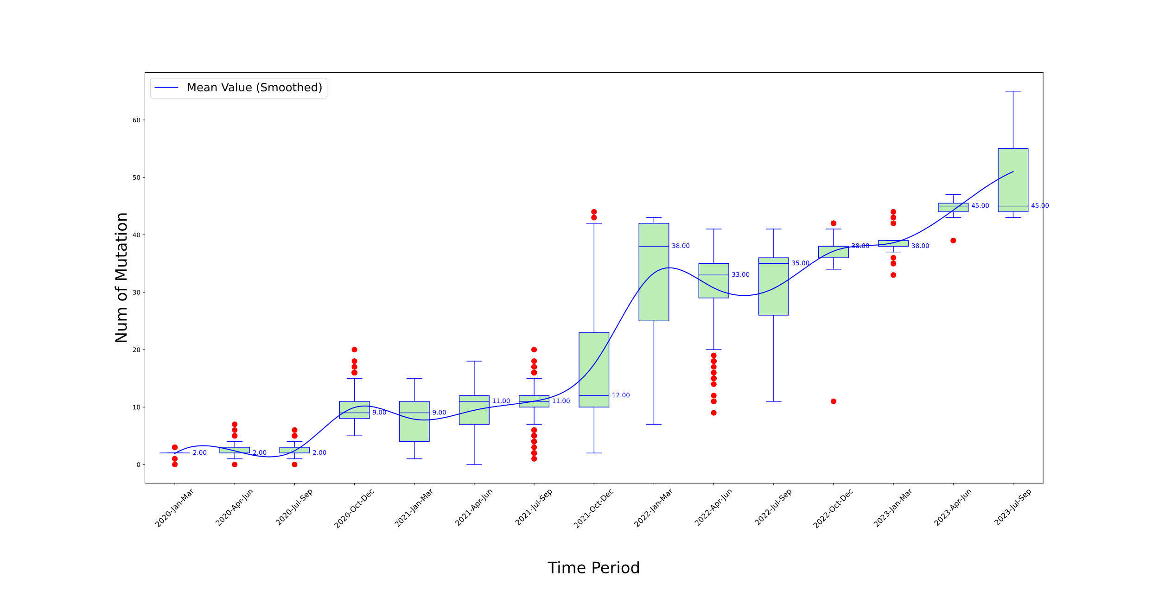

Supplementary Figure 1 Temporal analysis of mutational frequency per variant sequence in Africa from 2020 to 2023

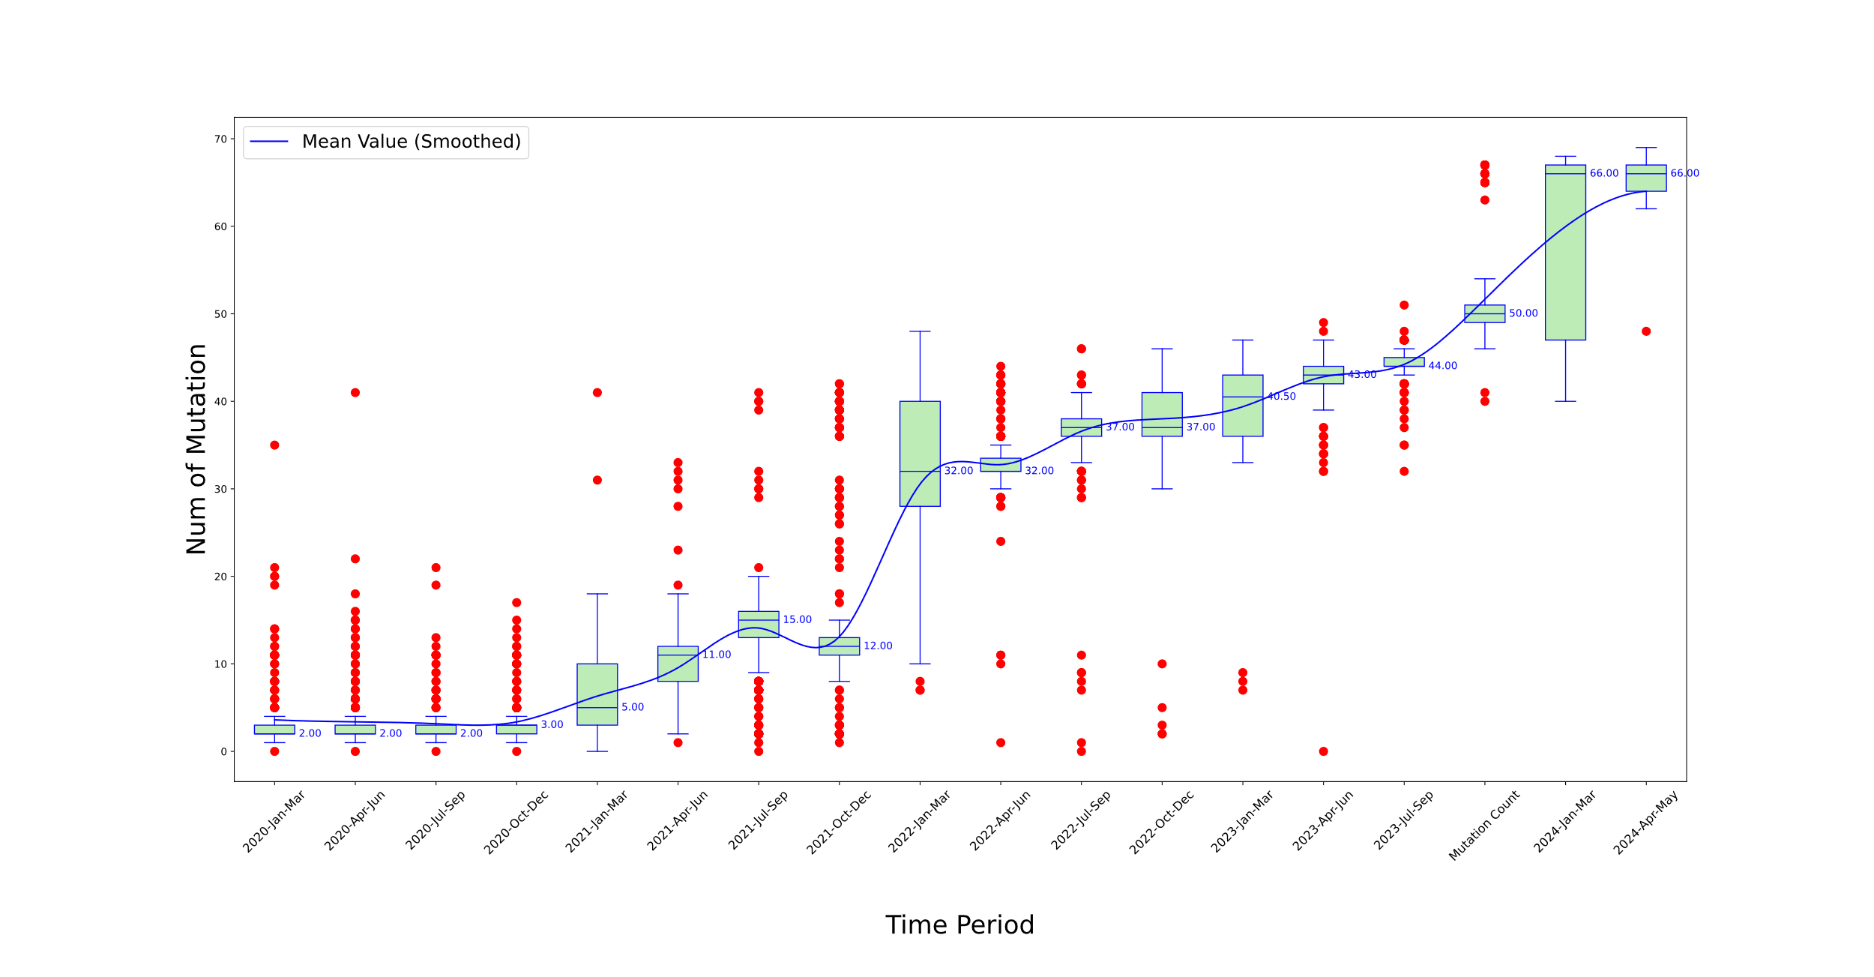

Supplementary Figure 2 Temporal analysis of mutational frequency per variant sequence in Asia from 2020 to 2024

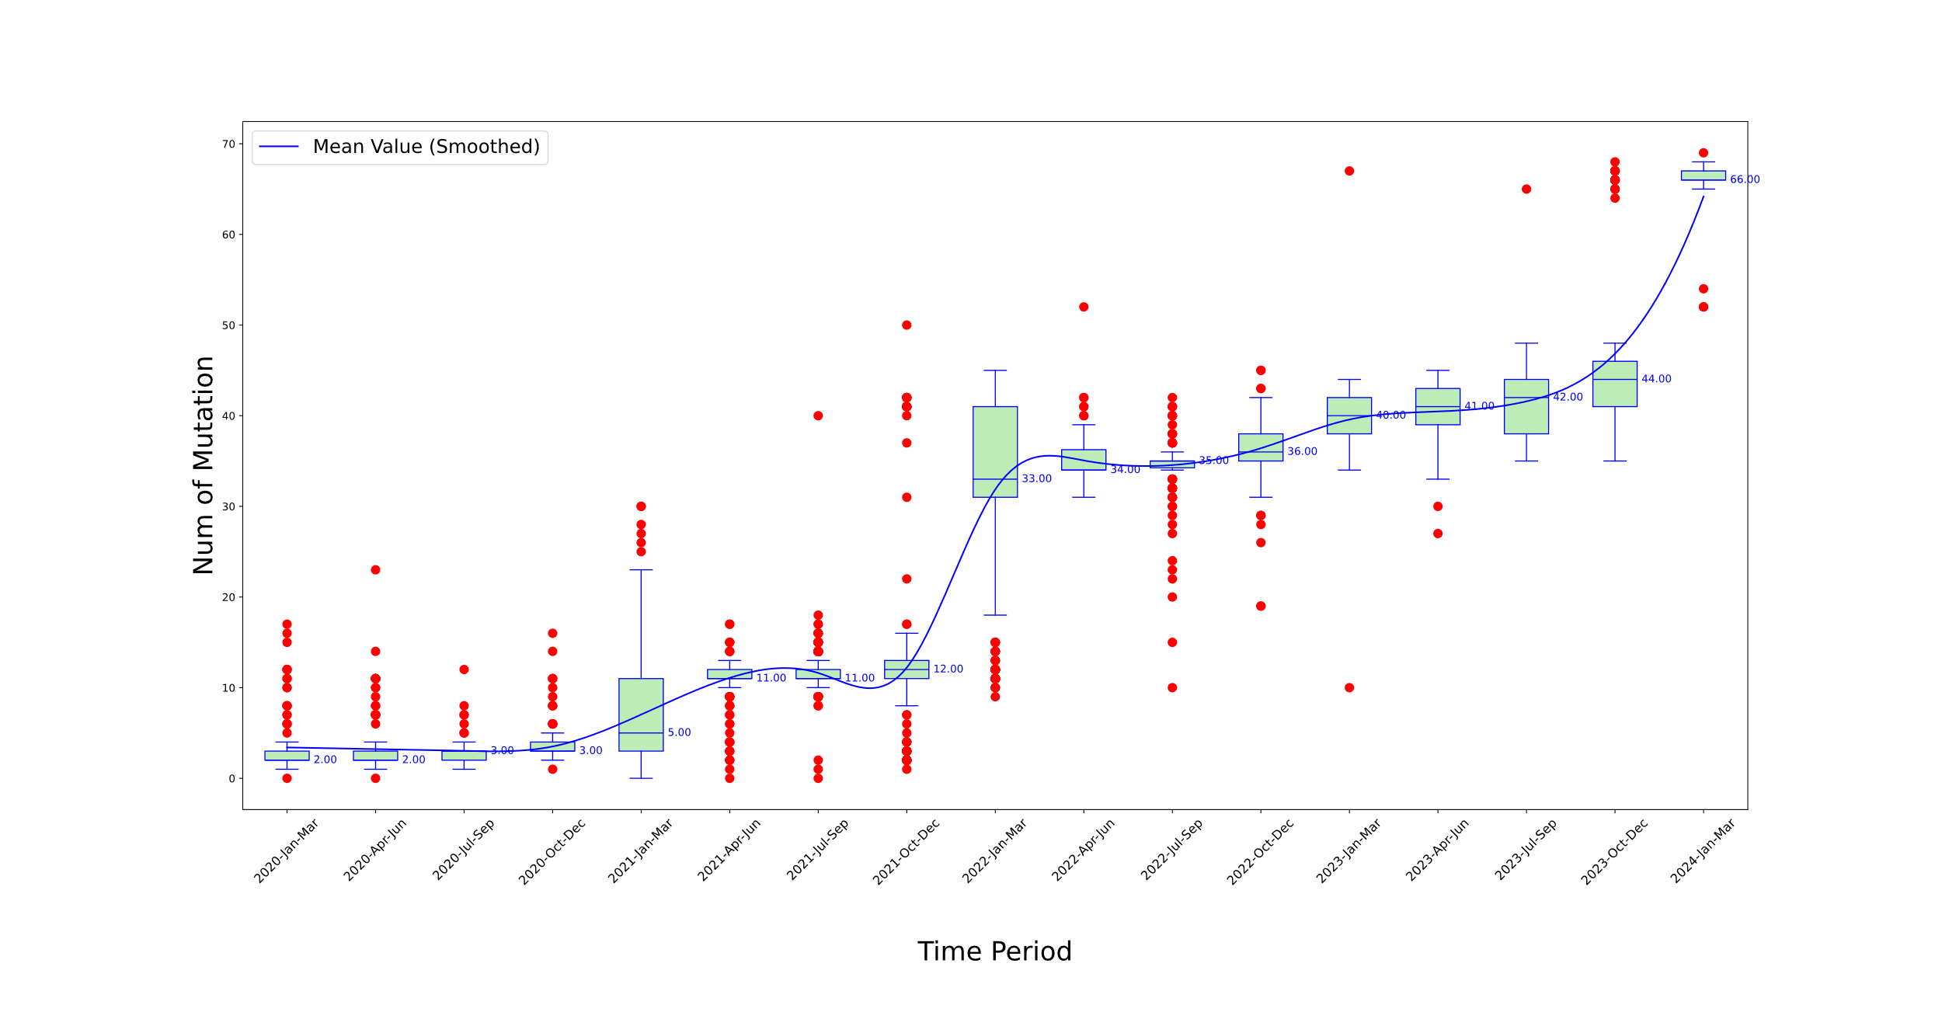

Supplementary Figure 3 Temporal analysis of mutational frequency per variant sequence in Europe from 2020 to 2024

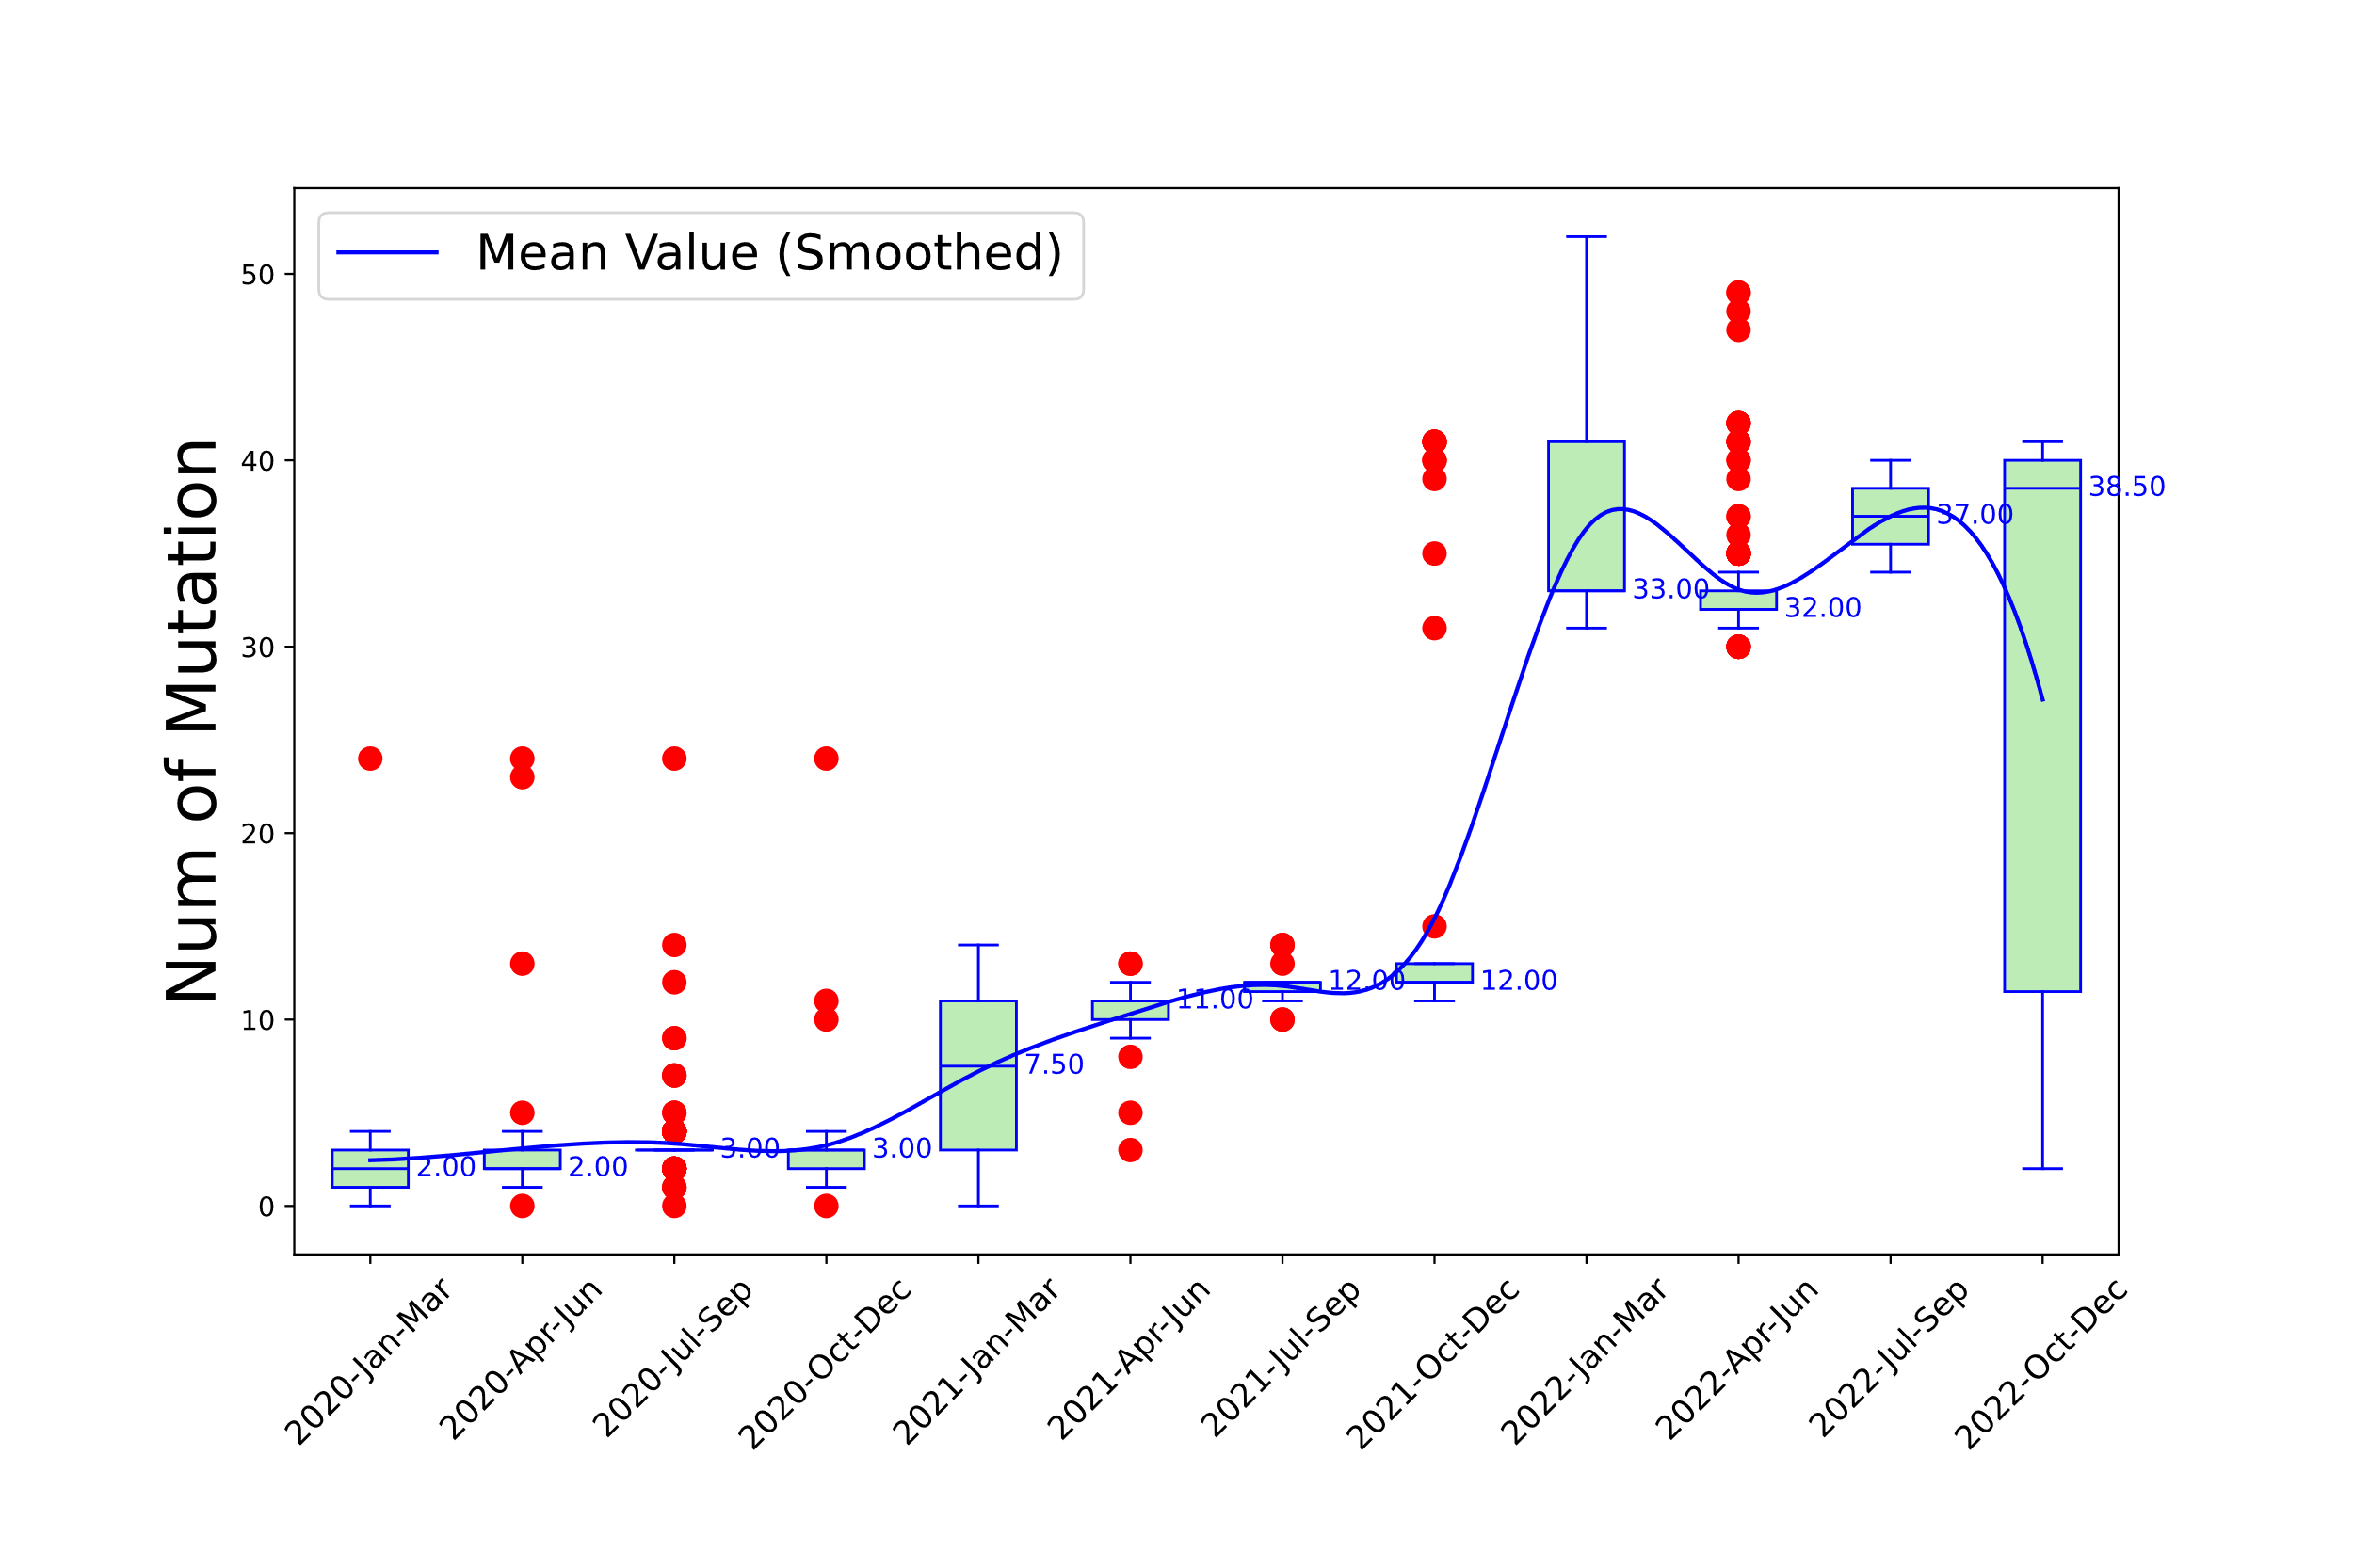

Supplementary Figure 4 Temporal analysis of mutational frequency per variant sequence in Oceania from 2020 to 2022

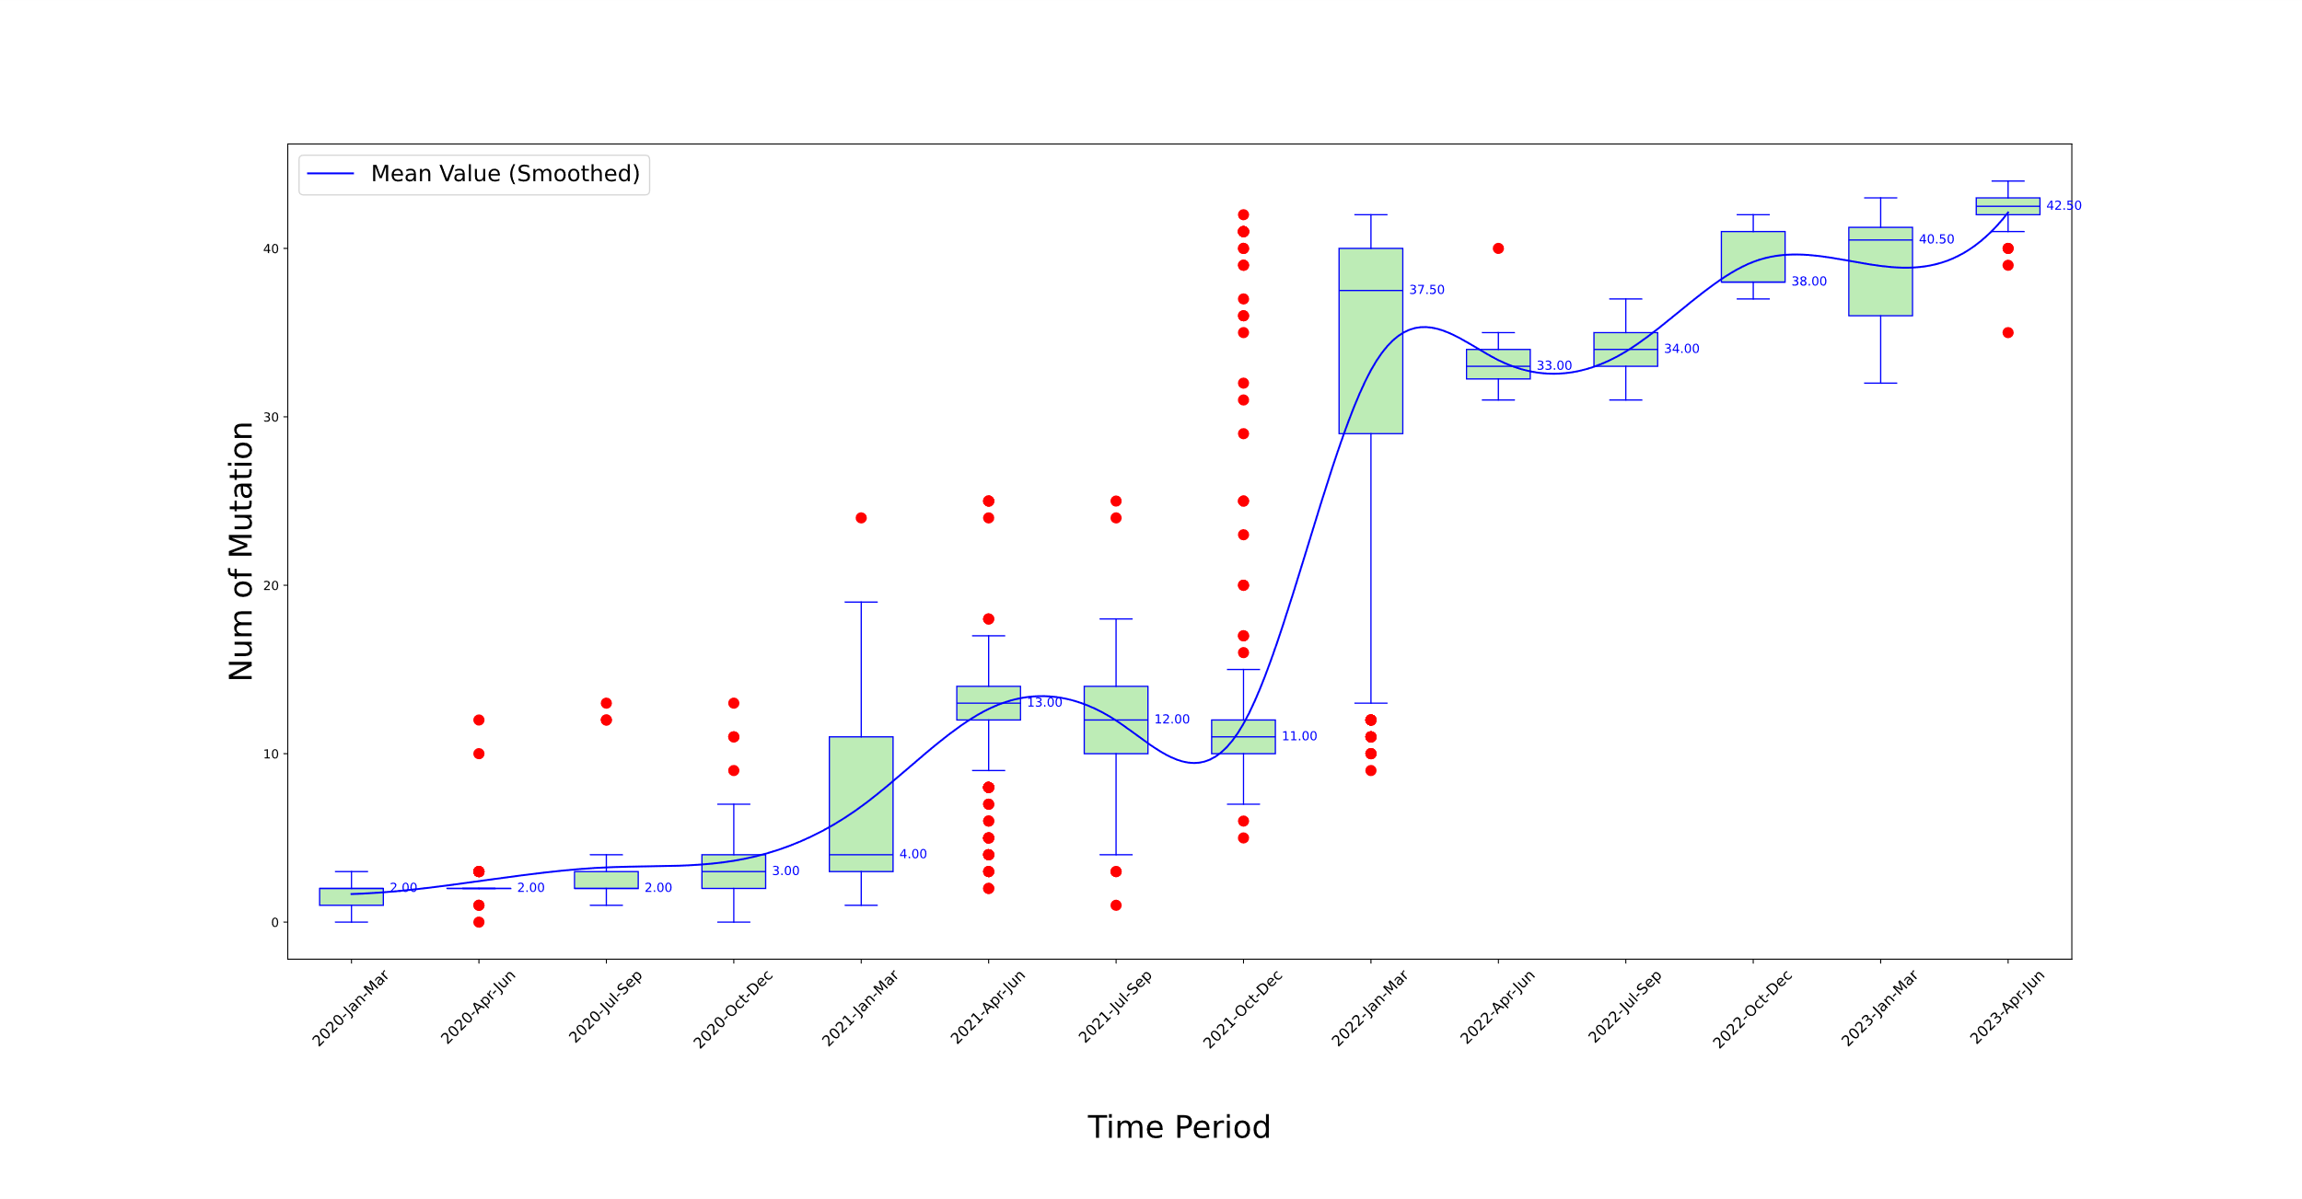

Supplementary Figure 5 Temporal analysis of mutational frequency per variant sequence in South America from 2020 to 2022

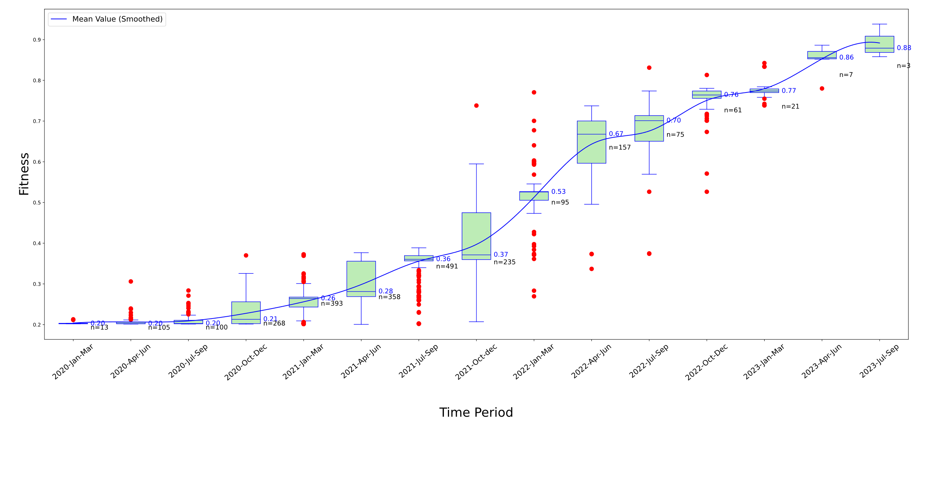

Supplementary Figure 6 Temporal analysis of Fitness levels for S protein variants in Africa over various time periods

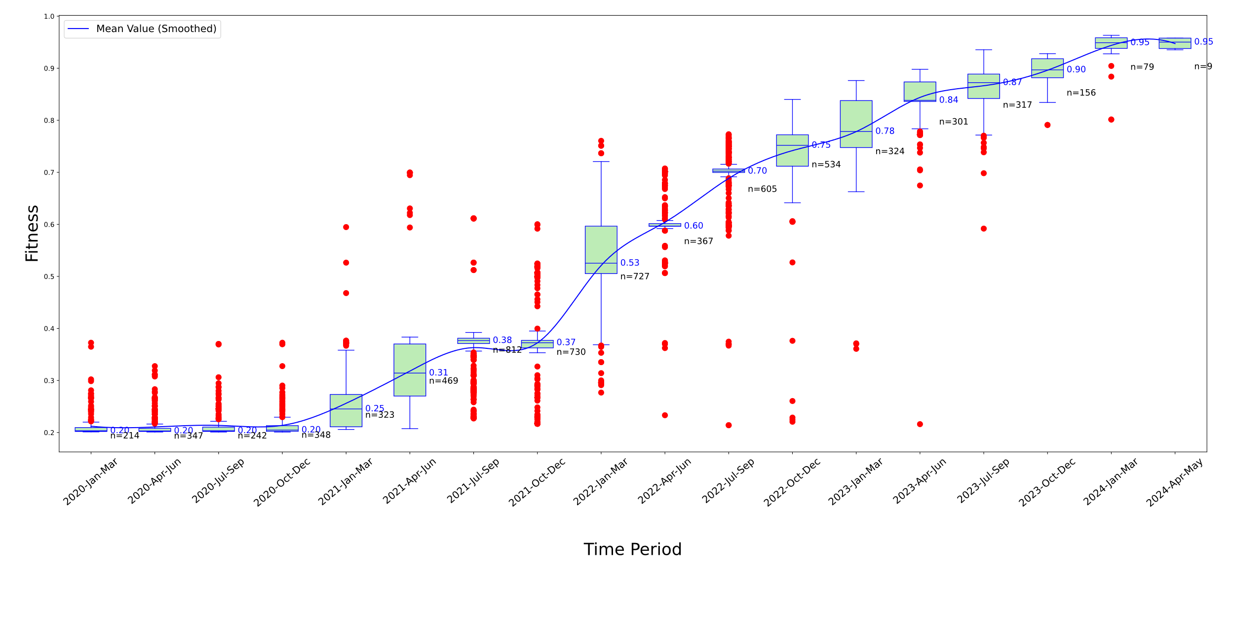

Supplementary Figure 7 Temporal analysis of Fitness levels for S protein variants in Asia over various time periods

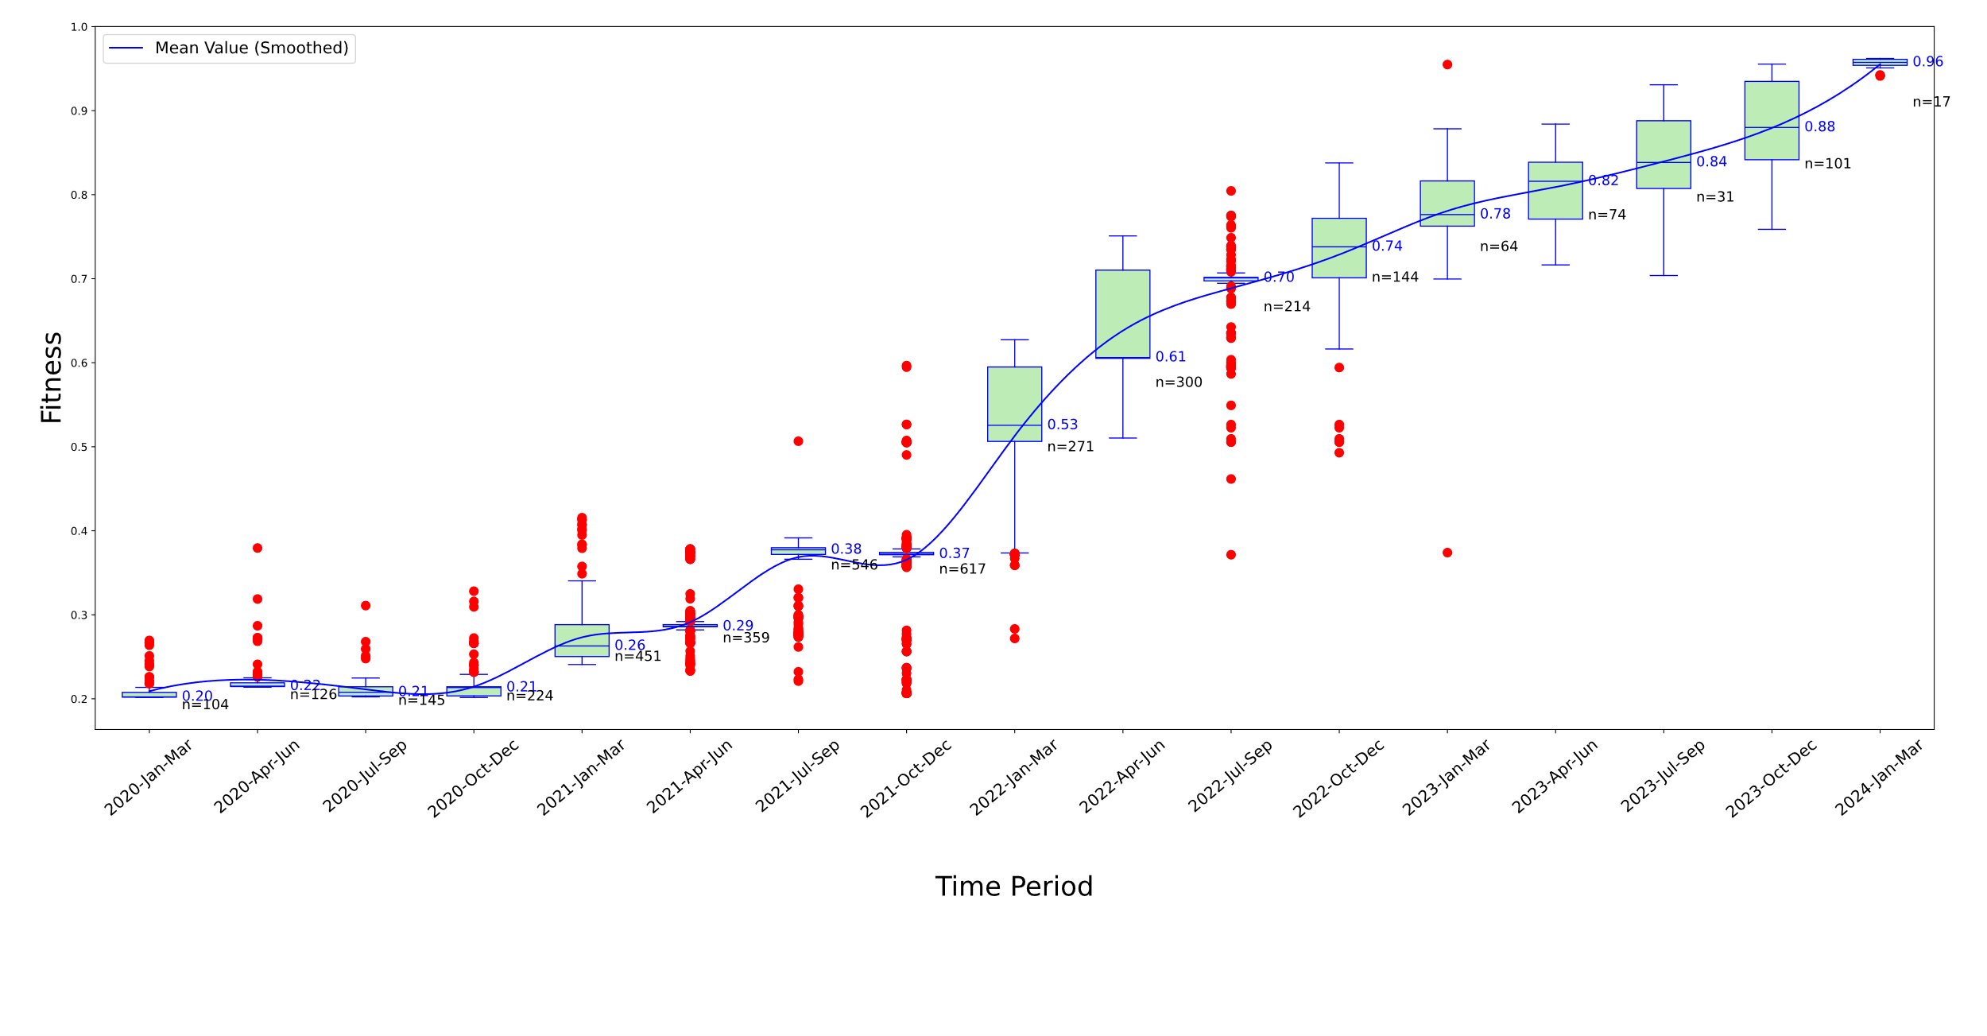

Supplementary Figure 8 Temporal analysis of Fitness levels for S protein variants in Europe over various time periods

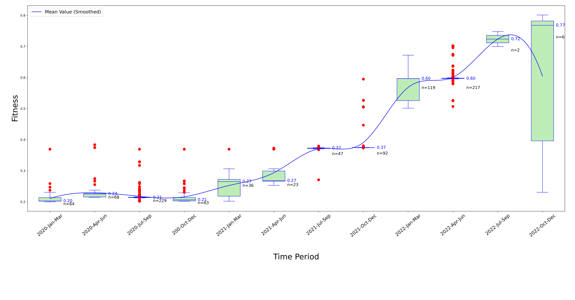

Supplementary Figure 9 Temporal analysis of Fitness levels for S protein variants in Oceania over various time periods

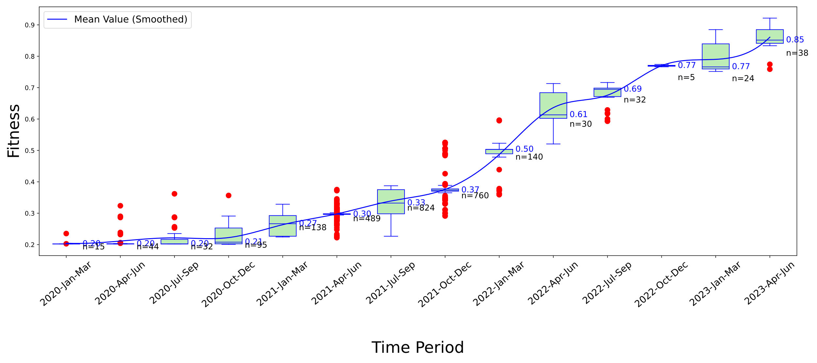

Supplementary Figure 10 Temporal analysis of Fitness levels for S protein variants in South America over various time periods

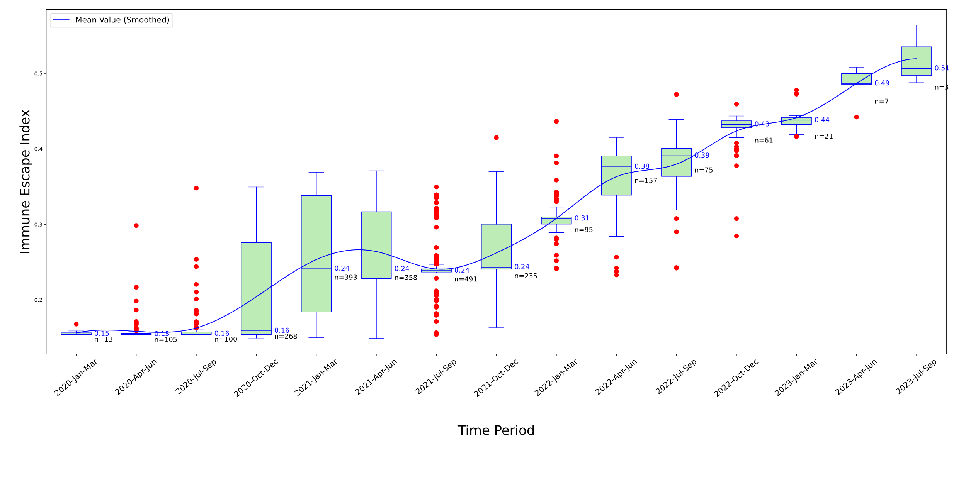

Supplementary Figure 11 Temporal analysis of Immune Escape Index for S protein variants in Africa

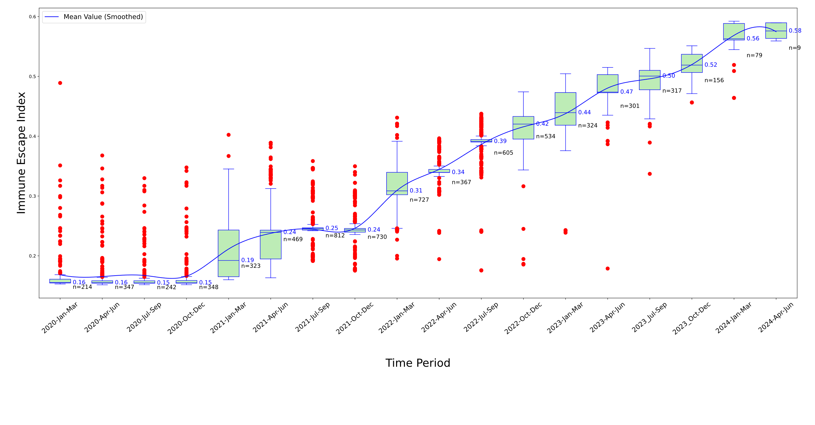

Supplementary Figure 12 Temporal analysis of Immune Escape Index for S protein variants in Asia

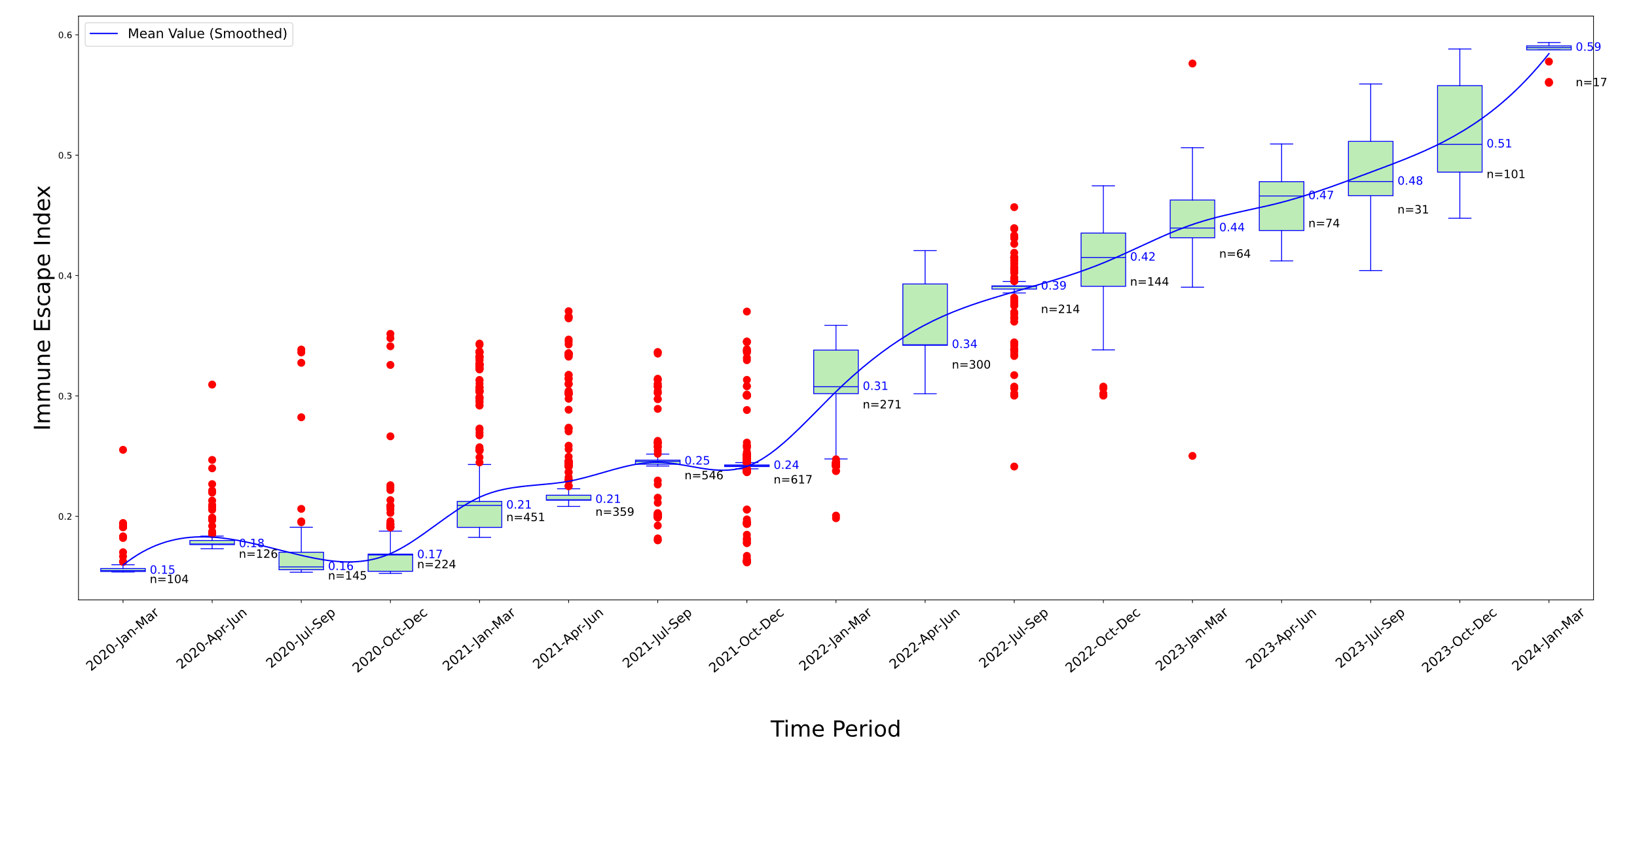

Supplementary Figure 13 Temporal analysis of Immune Escape Index for S protein variants in Europe

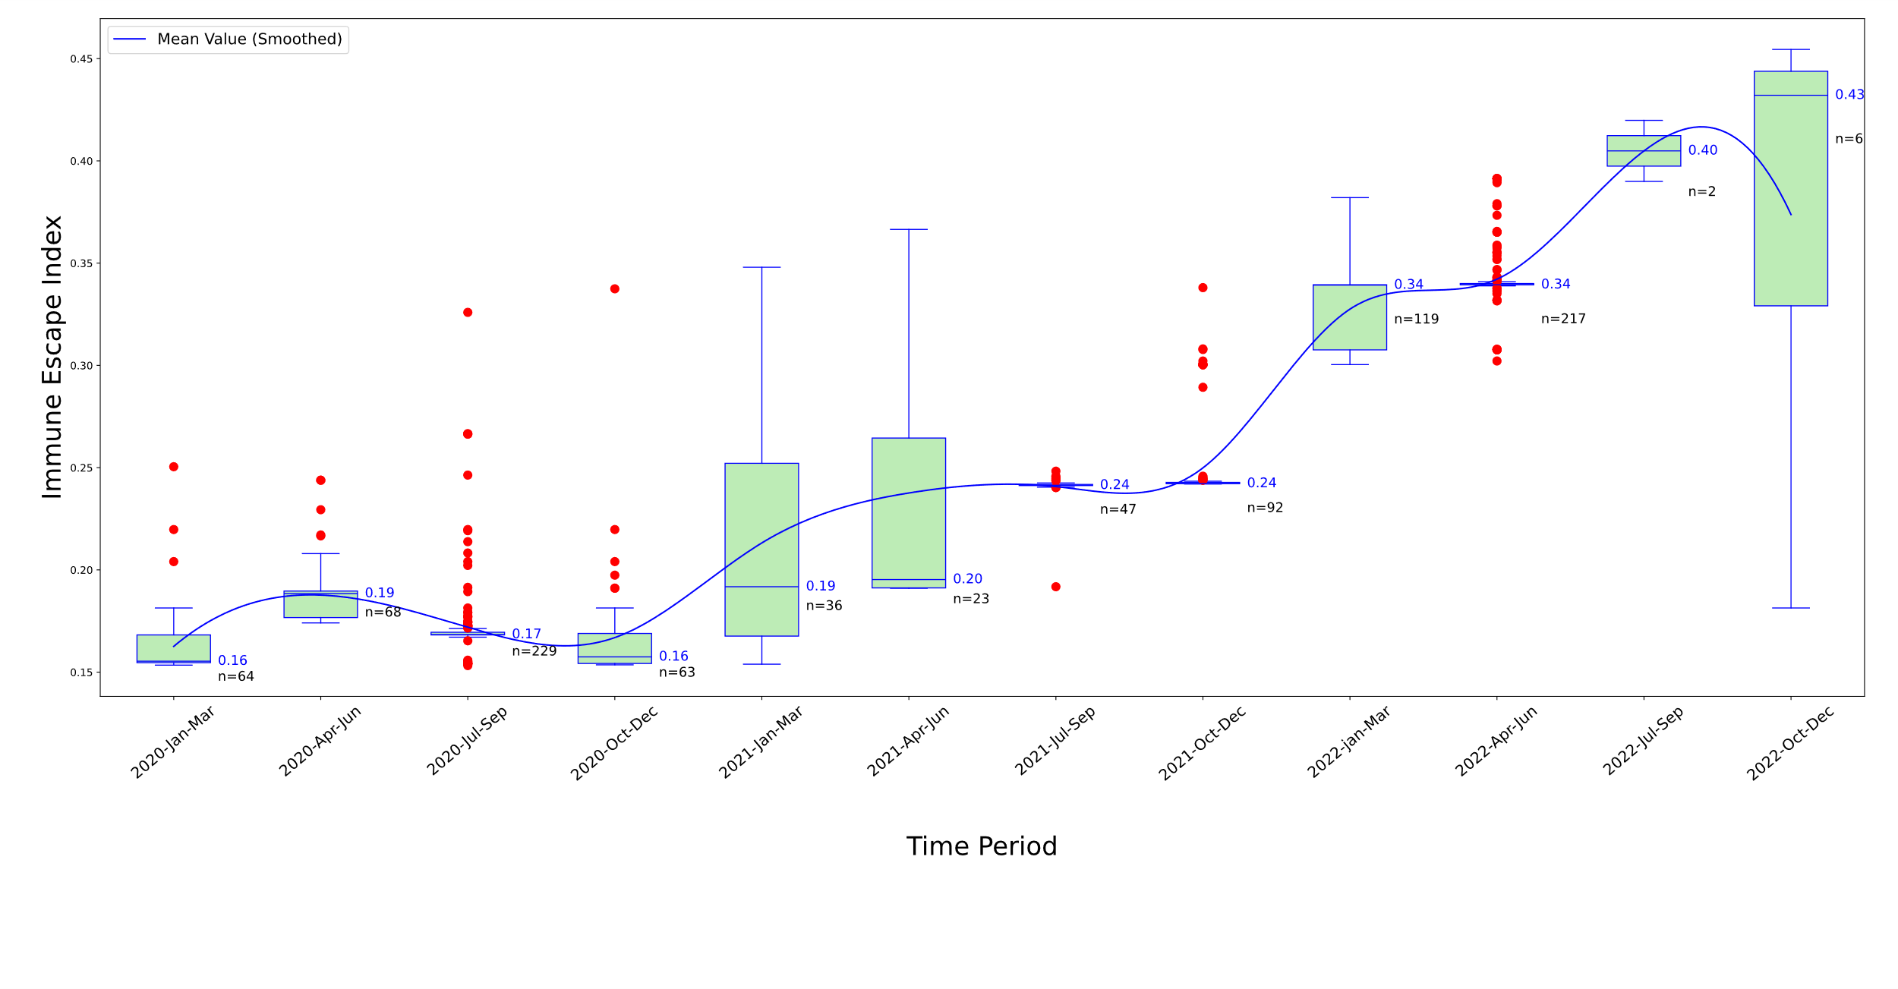

Supplementary Figure 14 Temporal analysis of Immune Escape Index for S protein variants in Oceania

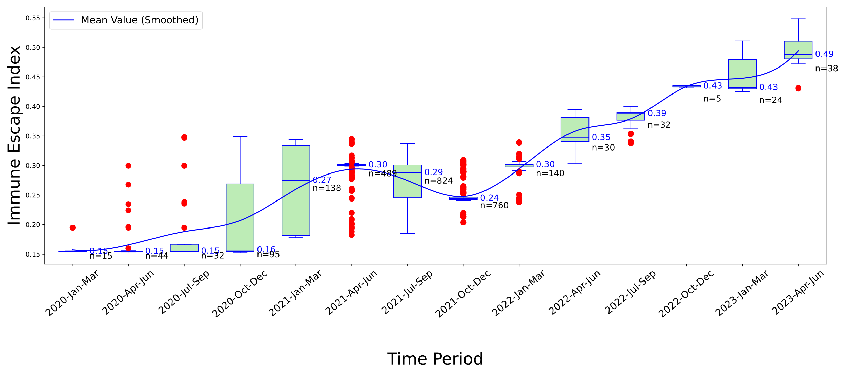

Supplementary Figure 15 Temporal analysis of Immune Escape Index for S protein variants in South America